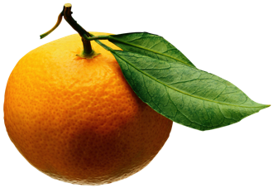
Ms. Albrecht’s Fresh Fruit Snack List
Please bring enough snack for your class for one snack *

AMBLE | Lara | Sept 9
BARBERO | Wyatt | Sept 16
BLACK | Griffin | Sept 23
BLIMPO | Sophia | Sept 30
BROWN | Zora | Oct 7
DUFIEF | Alphonse | Tuesday, Oct 15
IKEDA | Haru | Oct 21
IVANIC | Iva | Oct 28
JACKSON | Nicholas | Nov 4
JUREWICZ | Henry | Nov 11
PIEROLA-KITCHEN | Liam | Nov 18
RAHMAN | Ansharah | Nov 25
TAKAMI | Ayana | Dec 2
UEMATSU | Sakura | Dec 9
VECCHIO | Felipe | Jan 6
WANG | Anna | Jan 13
WEINER | Eli | Tuesday, Jan 21
WHITE | George | Jan 27
AMBLE | Lara | Feb 3
ANDERSON | Basil | Feb 10
BARBERO | Wyatt | Tuesday, Feb 18
BLACK | Griffin | Feb 24
BLIMPO | Sophia | Mar 2
BROWN | Zora | Mar 9
DUFIEF | Alphonse | Mar 16
IKEDA | Haru | Mar 23
IVANIC | Iva | Mar 30
JACKSON | Nicholas | Tuesday, Apr 14
JUREWICZ | Henry | Apr 20
PIEROLA-KITCHEN | Liam | Apr 27
RAHMAN | Ansharah | May 4
TAKAMI | Ayana | May 11
UEMATSU | Sakura | May 18
VECCHIO | Felipe | June 1
* Suggestions: Uncut – strawberries, berries, grapes (please wash), clementines, bananas, apples. Cut – melon, pineapple, mango, papaya

