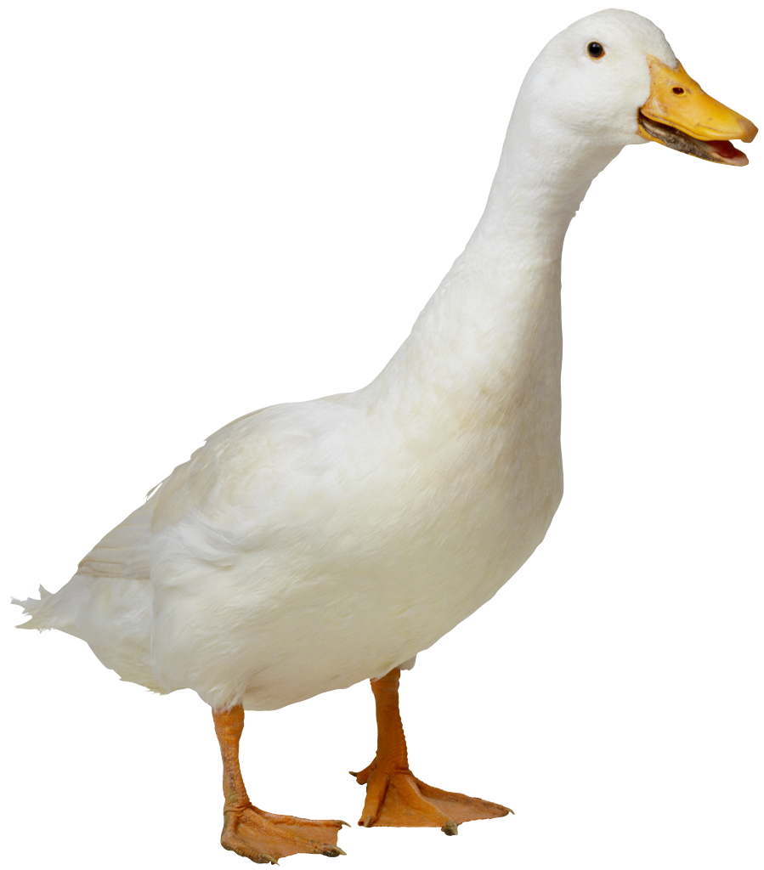
Mrs. Lu & Ms. Barbara
Fruit List
Please bring enough for 16 students for one day

ALZUBI | Abby | 10/4
BREECE | Alex | 10/11
COHEN | Miles | 10/18
DALY | Freya | 10/25
GACHOU | Gemma | 11/1
GLASS | Thomas | 11/8
GOONERATNE | Aarya | 11/15
HAJRI | Alya | 11/22
HUGHES | Jonathan | 11/29
LEE | Jeeyu | 12/6
CAPINERA | Nicola Alpay | 12/13
MHAISEN | Aya | 1/10
NIKOLAEV | Mila | 1/17
PEREZ | Louis | 1/24
SUKHATME | Sanvi | 1/31
VENUGOPAL | Vara | 2/7
VO | Leila | 2/15 WED
ALZUBI | Abby | 2/21
BREECE | Alex | 2/28
COHEN | Miles | 3/7
DALY | Freya | 3/14
GACHOU | Gemma | 3/21
GLASS | Thomas | 3/28
GOONERATNE | Aarya | 4/11
HAJRI | Alya | 4/18
HUGHES | Jonathan | 4/25
LEE | Jeeyu | 5/2
TOBITA | Kichi | 5/9
MHAISEN | Aya | 5/16
NIKOLAEV | Mila | 5/23

Suggestions: pre-cut fruit tray, pre-cut honey dew or cantalope, whole bananas (12 or more depending on size), apples (12 or more depending on size), clementines (30 if small, 15 if large), pre-washed grapes or berries.

