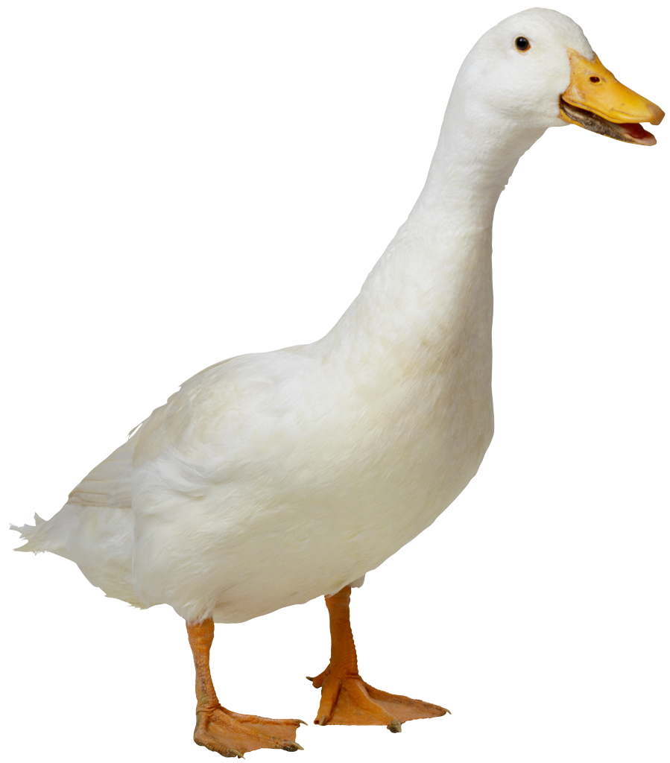
Mrs. Dabrowska, Ms. Anna,
Ms. Hortence
Fruit List 2022 for 20 students for one snack
ABIDI | Souheila | 10/4
BRAZAUSKAS | Alice | 10/11
CHUNG | Ruth | 10/18
DE SILVA | Asher | 10/25
DREYER | Ethan | 11/1
FUJIMAKI | Shunichi | 11/8
GARCIA-MARCOS | Marcos | 11/15
HYMAN | Yara | 11/22
KABBAJ | Ryan | 11/29
KALIBA | Benjamin | 12/6
KASHIPOUR | Sara | 12/13
KHAN | Maya | 1/10
KOSA | Seiichiro | 1/17
KUROSAKI | Ayaka | 1/24
MALAK | Carmen | 1/31
MATUS-NICODEMOS | Bruno | 2/7
MAZUR | Abigail | 2/15 WED
MCDONALD | Eleanor | 2/21
ONAKA | Koki | 2/28
ABIDI | Souheila | 3/7
BRAZAUSKAS | Alice | 3/14
CHUNG | Ruth | 3/21
DE SILVA | Asher | 3/28
DREYER | Ethan | 4/11
FUJIMAKI | Shunichi | 4/18
GARCIA-MARCOS | Marcos | 4/25
HYMAN | Yara | 5/2
KABBAJ | Ryan | 5/9
KALIBA | Benjamin | 5/16
KASHIPOUR | Sara | 5/23

Suggestions: pre-cut fruit tray, pre-cut honey dew or cantalope, whole bananas (12 or more depending on size), apples (12 or more depending on size), clementines (30 if small, 15 if large), pre-washed grapes or berries.

