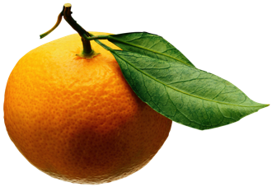
Mrs. Burr’s Fresh Fruit Snack List
Please bring enough fruit for your class for one serving *

ALBERT | Asher | Sept 9
CASAGRANDE | Raphael | Sept 16
DOSHI | Siddharth | Sept 23
EBARA | Sawako | Sept 30
FERRE | Ulysses | Oct 7
FROHLICH | Emily | Tuesday, Oct 15
GOGGIN | Eamon | Oct 21
GOGGIN | Maeve | Oct 28
 |  | Nov 4
HALEY | Eli | Nov 11
KIM | Amelia | Nov 18
KO | Asher | Nov 25
KOSARAS | Lilien | Dec 2
KOSARAS | Hedy | Dec 9
LEE | James | Jan 6
LEE | Allison | Jan 13
LINGENTHAL | Clara | Tuesday, Jan 21
LINGENTHAL | Isa | Jan 27
MATSUMOTO | Takumi | Feb 3
MANGOV | Alexandre | Feb 10
PAPAZIAN | Lila | Tuesday, Feb 18
PINHA | Bernardo | Feb 24
RIZAS | Thalia | Mar 2
SANDERS | Thelonious | Mar 9
SHIBLI | Maya | Mar 16
SHIRATORI | Nagisa | Mar 23
SIRMEN | Ozan | Mar 30
UOZUMI | Shunto | Tuesday, Apr 14
WANG | Alec & Aiden | Apr 20
LECKIE | Joseph | Apr 27
WHITE | Palmer | May 4
YOSHIKI | Haru | May 11
MEUWISSEN | Ella | May 18
 |  | June 1

* Suggestions: Uncut – strawberries, berries, grapes (please wash), clementines, bananas, apples, Cut – melon, pineapple, mango, papaya

