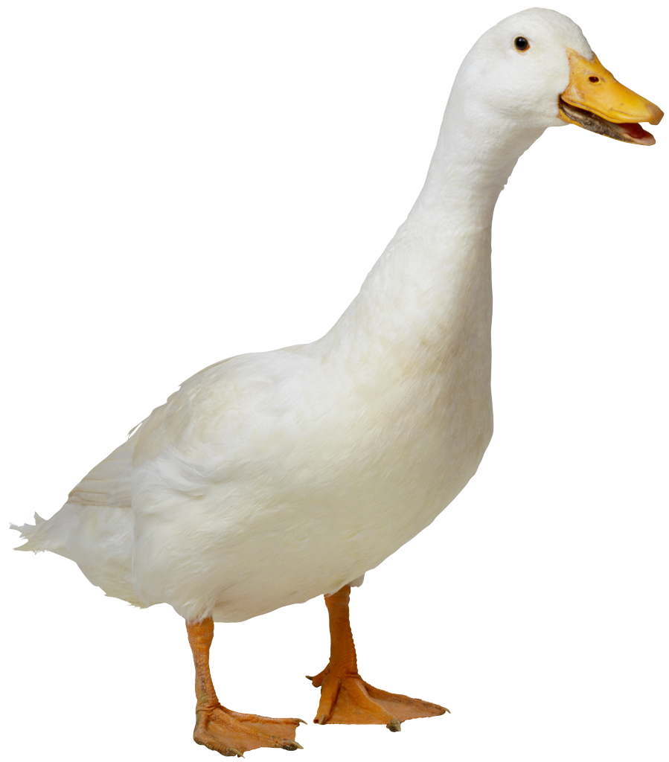
Mrs. Dabrowska, Ms. Anna,
Ms. Vasquez
Fruit List 2021 for 22 students for one day
ADAM | Artemis | 10/19
ALBERT | Kaiahsin | 10/26
BANNISTER | Carys | 11/2
BANNISTER | Nia | 11/9
BUEHLER | Ingrid | 11/16
CHIZHIK | Ari | 11/23
FRIEDLAND | Addie | 11/30
FUJIMAKI | Shunichi | 12/7
ISRAILEVICH | Sofia | 12/14
KABBAJ | Ryan | 1/4
KANIE | Kengo | 1/11
KHAN | Maya | 1/18
LERCHNER | Christopher | 1/25
MACHIMURA | Misato | 2/1
MALAK | Carmen | 2/8
MANGANI | Ralfie | 2/15
NAITO | Yuki | 2/22
SHI | Runlin | 3/1
TARRALLE | Alexia | 3/8
VACA | Miles | 3/15
YAMAZAKI | Shiori | 3/22
YELLIN | Max | 3/29
ADAM | Artemis | 4/5
ALBERT | Kaiahsin | 4/19
BANNISTER | Carys & Nia | 4/26
BUEHLER | Ingrid | 5/3
CHIZHIK | Ari | 5/10
FRIEDLAND | Addie | 5/17
FUJIMAKI | Shunichi | 5/24
ISRAILEVICH | Sofia | 5/31

Suggestions: pre-cut fruit tray, whole bananas, apples, clementines, pre-washed grapes or berries. NO KIWI IN THIS CLASS PLEASE.

