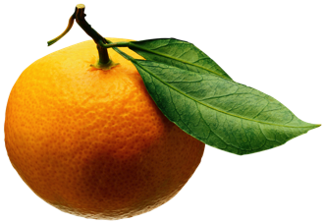
Mrs. Kelsey’s Monday “Fresh Fruit” Snack List
Please bring enough fruit for your class for one snack
ANANTHAM | Leah | Sept 9
AUDY | Logan | Sept 16
CAMPANTE | Isabel | Sept 23
CATTRELL | Sawyer | Sept 30
DRICHTA | Jony | Oct 7
ERTAY | Can | Tuesday, Oct 15
GABRIEL | Mary Mae | Oct 21
GERHARZ | Emma | Oct 28
GUJDA | Valentina | Nov 4
HOLMGREN | Caroline | Nov 11
ITO | Kaho | Nov 18
MORITA | Eric | Nov 25
NAHZI | Nikolas | Dec 2
PIEROLA-KITCHEN | Noah | Dec 9
PINKARD | Gavin | Jan 6
POWELL | Idris | Jan 13
RASTOGI | Rishaan | Tuesday, Jan 21
REDDY SAKS | Kavya | Jan 27
VACA (Jan 2020) | Miles | Feb 3
WILDE | Kayla | Feb 10
YOSHINAGA | Yui | Tuesday, Feb 18
ZETTERLI | Finn | Feb 24
ANANTHAM | Leah | Mar 2
ANDERSON | Ivy | Mar 9
AUDY | Logan | Mar 16
CAMPANTE | Isabel | Mar 23
CATTRELL | Sawyer | Mar 30
DIAZ | Rosario | Tuesday, Apr 14
DRICHTA | Jony | Apr 20
ERTAY | Can | Apr 27
GABRIEL | Mary Mae | May 4
GERHARZ | Emma | May 11
GUJDA | Valentina | May 18
HOLMGREN | Caroline | June 1

Suggestions: Uncut – strawberries, berries, grapes (please wash), clementines, bananas, apples, Cut – melon, pineapple, mango, papaya

